VTP Configuration with Ether Channel in Packet Tracer

# Introduction

Virtual local area network (VLAN) trunking Protocol or VTP is a proprietary protocol from Cisco that allows networks to send network functionality through all of the switches in a domain. This technique eliminates the need for multiple configurations for VLANs throughout the system.

EtherChannel is a port link aggregation technology in which multiple physical port links are grouped into one logical link. It is used to provide high-speed links and redundancy. A maximum of 8 links can be aggregated to form a single logical link.

Contents

Introduction 1

1. For VTP Configuration, we will use the topology below with two switches and two PCs. 3

3

2. Create Vlan10 and vlan20 on server Switch. 4

3. In Server Switch: Assign switchports to vlans : 5

4. Setup Ether Channel Between switches: 6

IN SERVER SWITCH 6

IN CLIENT SWITCH: 7

5. VTP Client And VTP Server Configuration 7

For Client Switch: 7

For ServerSwitch: 8

6. To verify VTP configuration, 8

7. Check on Client Switch using ‘show vlan’ command.Output looks like: 9

8. Conclusion 9

9. Problem Faced: 9

10.References 10

# For VTP Configuration, we will use the topology below with two switches and two PCs.

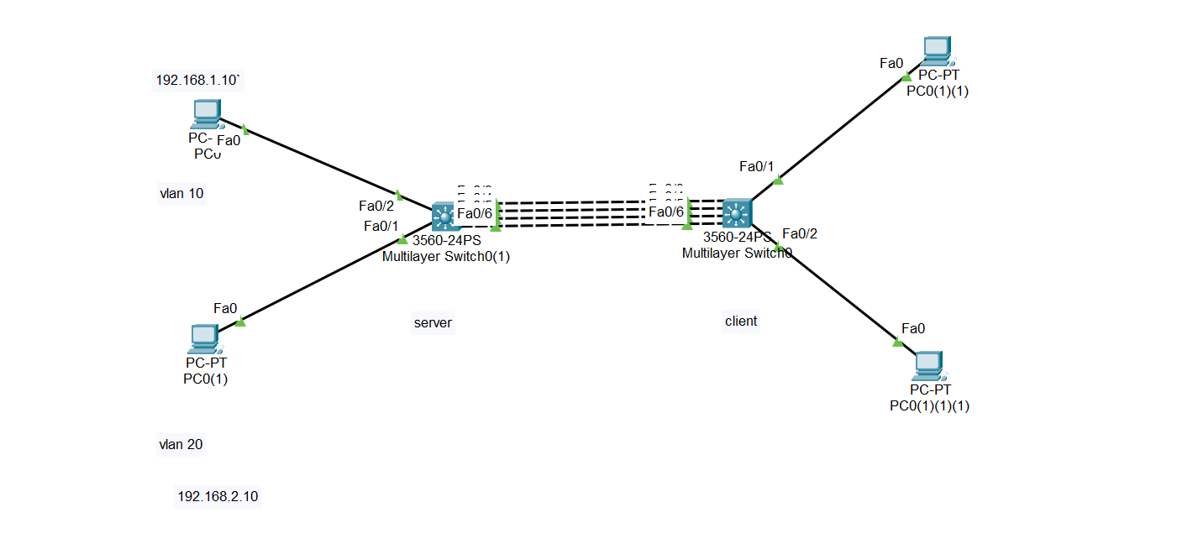

Fig 1: Network Topology in Packet Tracer

At first , Configure PC) ,PC0(1) and setup Server Switch only.

# 2. Create Vlan10 and vlan20 on server Switch.

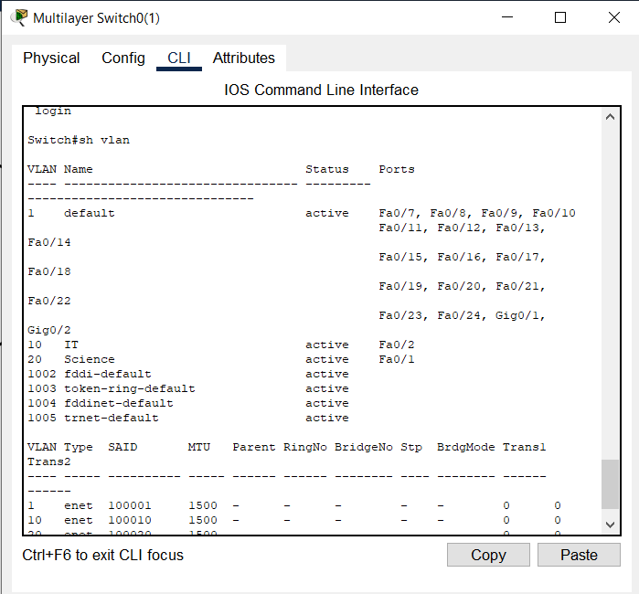

# In Server Switch: Assign switchports to vlans :

i.Access port

ii.Trunk port

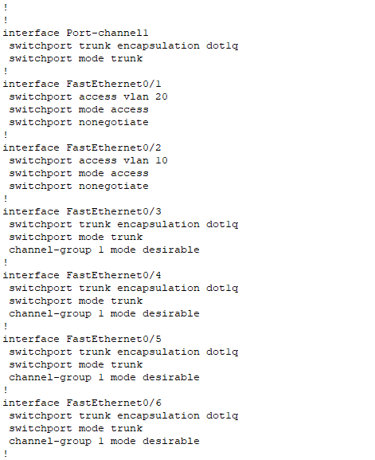



# Setup Ether Channel Between switches:

We used Port Aggregation Protocol (PAgP).

It’s a type of data/traffic load balancing that involves the logical aggregation of Cisco Ethernet switch ports. A PAgP EtherChannel can merge up to eight physical links into one virtual link.

## IN SERVER SWITCH

**S1(config)#** interface fa0/1

**S1(config-if)#** channel-group 1 mode desirable

**S1(config)#** interface fa0/2

**S1(config-if)#** channel-group 1 mode desirable

**S1(config)#** interface port-channel 1

**S1(config-if)#** switchport trunk encapsulation dot1q

**S1(config-if)#** switchport mode trunk

## **IN CLIENT SWITCH:**

**S2(config)#** interface fa0/1

**S2(config-if)#** channel-group 1 mode auto

**S2(config)#** interface fa0/2

**S2(config-if)#** channel-group 1 mode auto

**S2(config)#** interface port-channel 1

**S2(config-if)#** switchport trunk encapsulation dot1q

**S2(config-if)#** switchport mode trunk

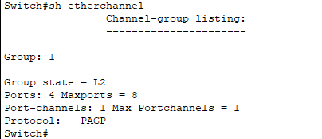

# VTP Client And VTP Server Configuration

After that we configure Switch A as a **VTP Server** and the Switch B as a **VTP Client**. The default switch VTP mode is VTP Server, so we did not change anything on SwitchA. But in SwitchB we will change vtp mode. Then in both switches we will configure VTP domain, VTP password, vtp version and vtp prunning. The related configuration for both switches are below:

## For Client Switch:

Switch> **enable**

Switch# **configure terminal**

Switch(config)# **vtp mode client**

Setting device to **VTP CLIENT mode.**

Switch(config)# **vtp domain cisco**

Changing **VTP domain** name from NULL to cisco

Switch(config)# **vtp password cisco123**

Switch(config)# **vtp version 2**

## For ServerSwitch:

Switch# **enable**

Switch(config)# **vtp mode server**

Device mode already **VTP SERVER**.

Switch(config)# **vtp domain ciscoo**

Changing VTP domain name from NULL to ciscoo

04:50:49 %DTP-5-DOMAINMISMATCH: Unable to perform trunk negotiation

on port Fa0/24 because of VTP domain mismatch.

Switch(config)# **vtp domain cisco**

Changing VTP domain name from ciscoo to cisco

Switch(config)# **vtp password cisco123**

Switch(config)# **vtp version 2**

1. To verify VTP configuration,

use **“show vtp status”**

and the output of this command will be like below:

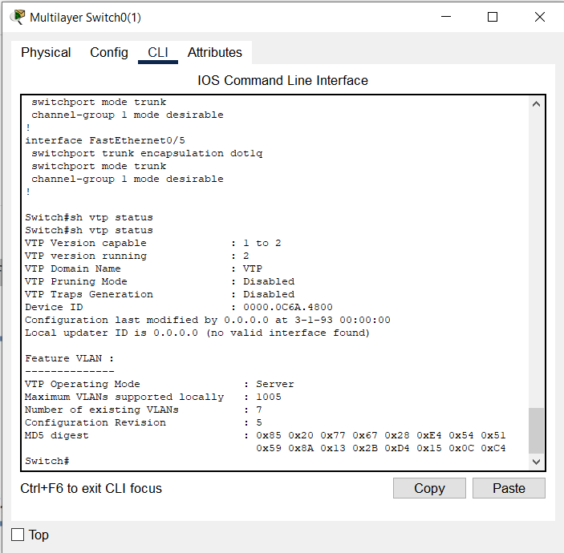

# Check on Client Switch using ‘show vlan’ command.Output looks like:

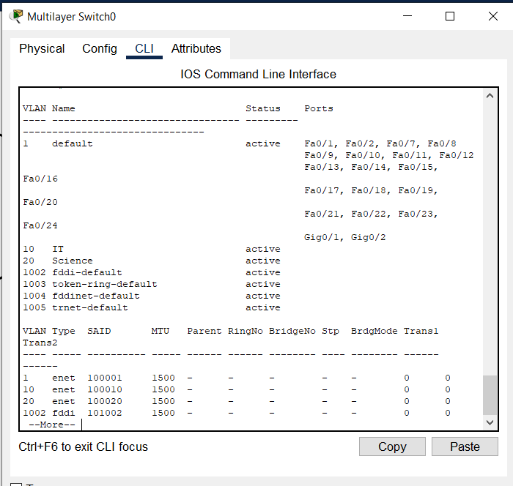

# Conclusion

Finally ,We copied configurations on client Switch simply using VTP without manually configuring.

# Problem Faced:

Here, during **VTP domain configuration**, an error occurred because of the **domain missmatch** and after that when we corrected the configuration then this error dissappeared.

# 10.References

1. <https://computernetworking747640215.wordpress.com/2018/07/05/vlan-configuration-on-a-cisco-switch-in-packet-tracer/>

2. <https://www.geeksforgeeks.org/etherchannel-in-computer-network/>

3. <https://ipcisco.com/lesson/vtp-configuration-with-packet-tracer/#:~:text=Packet%20Tracer%20VTP%20Configuration,-In%20this%20article&text=For%20VTP%20Configuration%2C%20we%20will,two%20switches%20and%20two%20PCs.&text=You%20can%20DOWNLOAD%20the%20Packet,check%20Packet%20Tracer%20Labs%20Page>.